**ONLINE MUSIC STREAMER (SONGBOOK)**

**A PROJECT REPORT**

***Submitted by***

**AJAY JANGID [1519BECE30129]**

**MOHIT RAJPUT [1519BECE30160]**

**PRATIK WAGH [1519BECE30164]**

**SOHAM PATEL [1519BECE30178]**

***In fulfillment for the award of the degree***

***Of***

**BACHELOR OF ENGINEERING**

**In**

**COMPUTER ENGINEERING**



**LDRP INSTITUTE OF TECHNOLOGY AND RESEARCH, GANDHINAGAR**

**Kadi Sarva Vishwavidyalaya, Gandhinagar**

**2015 - 2019**

**LDRP Institute of Technology and Research**

Computer Engineering Department



**CERTIFICATE**

This is to certify that the Project Work entitled **“ONLINE MUSIC STREAMER”** has been carried out by **Ajay Jangid, Mohit Rajput, Pratik Wagh and Soham Patel** under my guidance in fulfilment of the degree of Bachelor of Engineering in Computer Engineering (7th Semester) of Kadi Sarva Vishwavidyalaya University, Gandhinagar during the academic year 2018-19.

**Guide:**

**Prof. Hitesh Patel Prof. Hiren B Patel**

Internal Guide, H.O.D. CE Dept.,

LDRP-ITR. LDRP ITR.

**ACKNOWLEDGEMENT**

We express our unfathomable sense of pleasure towards ***Mrs.Gargi Rajpara*** Principle of *LDRP-ITR*, who gave us a chance to work. She frequently came to motivate and provided such an extraordinary infrastructure and resources to work in her premises.

We express our deep sense of gratitude and indebtedness to our internal guide ***Mr. Hitesh Patel*** for accepting us to work under her training and supervision. She took prolonged interest in our work and directed to us toward the predefined goal. She has shown us a way to pursue excellence. She has been a big factor of motivation in our project.

We are also very thankful to our HOD of CE/IT department ***Prof. Hiren B Patel*** and all the faculty members who provided to be a constant motivation for the knowledge acquisition and the moral support throughout the whole project.

We sincerely thank our Computer Engineering Department, ***LDRP-ITR*** for the academic advancement it has provide to us during the whole Engineering degree and provided an opportunity for project training.

Last but not the least my heartily thanks is to my friends and batch mates, who have provided us with innumerable discussions on many technicalities and friendly tips.

We would like to express our heartiest gratitude to our family and friends who has always guided us towards the path of success and those entire people who have directly or indirectly helped us in making this project work successful.

**Ajay Jangid**

**(1519BECE30129)**

**Mohit Rajput**

**(1519BECE30160)**

**Pratik Wagh**

**(1519BECE30164)**

**Soham Patel**

**(1519BECE30178)**

**ABSTRACT**

Playing music has become an Integral part of us. However, with increase in music lovers, there has also been increase in piracy of music, the reason being high pricing. This app solves the same. It partners with music and record companies to provide DRM protected music content to its users which, as of now is freely available. Also users can be up to date with the trending songs and their artists. Being an online streaming app, user can find and enjoy it’s music without the hassle of finding and downloading each song.

**TABLE OF CONTENTS:**

Acknowledgement iii

Abstract iv

List of Figures v

1. **Introduction 1**
   1. Introduction 2
   2. Scope 2
   3. Project summary and Purpose 2
   4. Objectives 3
2. **Technology and Literature Review 4**
   1. About Tools and Technology 5
   2. Brief History of Work Done 5
3. **System Requirements Study 6**
   1. User Characteristics 7
   2. Software Requirements 7
   3. Constraints 7
      1. Parallel Operations 7
      2. Reliability Requirements 8
      3. Criticality of the Application 8
      4. Safety and Security Consideration 8
      5. Hardware Limitations 8
      6. Regulatory Policies 8
   4. Assumptions and Dependencies 9
4. **System Analysis 10**
   1. Study of Current System 11
   2. Feasibility Study 11
   3. Requirements Validation 13
   4. E-R Diagram
   5. Class Diagram 13
   6. System Activity(Use case and/or scenario diagram) 15

4.7 Sequence Diagram 18

4.8 Activity Diagram

1. **System Design 20**
   1. Database Design 21

**Bibliography 26**

**LIST OF FIGURES**

|  |  |  |
| --- | --- | --- |
| **NO** | **NAME** | **PAGE NO** |
|  |  |  |
| 1 | Class Diagram | 14 |
| 2 | Use case for System | 16 |
| 3 | Use case for Prediction | 17 |
| 4 | Sequence Diagram | 19 |

5 DD for user Details 21

6 DD for songs Details 21

**7**  DD for artist Details 22

8 DD for album details

9 DD for genre

# 1 INTRODUCTION

* 1. **Introduction**

Purpose and Motivation

The objective of this project is to implement a Music streamer user interface. The motivation of this project comes from our desire to learn the increasingly growing field of SQL server database designing, website designing and their growing popularity by taking up this case study.

The word “design” in the context of a Web Application can mean many things. Its most popular usage probably refers to the visual and user interface (UI) design of a web site. This aspect is crucial because, the visitor is often more impressed with how a website looks and how easy it is to use than about which technologies and techniques are used behind the scenes, or what operating system the web server is running. If the site is hard to use and easy to forget, it just doesn’t matter what technologies was used to create it. Unfortunately, this truth makes many inexperienced programmers underestimate the importance of the way the invisible part of the site is implemented—the code, the database, and so on. The visual part of a site gets visitors interested to begin with, but its functionality makes them come back. A web site can sometimes be implemented very quickly based on certain initial requirements, but if not properly architected, it can become difficult, if not impossible, to change.

Thus, performance is also a major thrust area in the Web application which is one of the main reasons why users get attracted to it. Growing user needs should be taken in to concern with new features to be included.

* 1. **Scope**

**1.2.1 Current Scope**

Search and play your favourite song directly through your browser without downloading any app.

**1.2.2 Future Scope**

Adding personalized playlists for each user.

Implementing machine learning to predict users favourite songs.

Adding radio stations of various genres.

* 1. **Project summary**

Songbook is a online music streaming service where users can listen to their favourite songs on the go. The users don’t need to download songs on their device which inturn saves storage space and the hassle to search and download each song. Users can also create their own personalized playlist accessible to them anywhere, anytime. Users can share their playlists on any social media platform.

* 1. **Objectives**

There are objectives that specify how the system should work for fulfilling the purpose of developing it. Below are the objectives for Songbook:

* The system should provide good user interface.
* This system should minimize complexity and should provide efficiency.
* The application should consume less memory space and should fit in any device without taking much time for loading.
* This system should provide security as we are dealing with the databases.
* This system should be flexible enough of being updated.
* The system should provide password and email recovery.

# 2 TECHNOLOGY AND LITERATURE REVIEW

**2.1 Tools and Technology**

**2.1.1 HTML, CSS, JS, JQuery:**

HTML stands for Hypertext Markup Language and CSS stands for Cascading Style Sheets are the crucial technologies for creating web pages. HTML supplies the structure of the page, and CSS the layout, for diversity of devices. Together with scripting and graphics, HTML and CSS are the fundamental of building Web Applications and Web pages. Javascript is a dynamic computer programming language. It is lightweight and most commonly used as a part of web pages, whose implementations allow client-side script to interact with the user and make dynamic pages. It is an interpreted programming language with object-oriented capabilities.

**2.1.2 PHP:**

(recursive acronym for *PHP: Hypertext Preprocessor*) is a widely-used open source general-purpose scripting language that is especially suited for web development and can be embedded into HTML. We are using AJAX and JSON for communication between the frontend (Javascript) and backend server (PHP itself).

# 3 SYSTEM REQUIREMENTS STUDY

**3.1 User Characteristics**

Students and companies that recruit students can use this system. No prior knowledge needed to operate this website although:

* User must have a device either PC or Mobile phone.
* User must have any kind web browser.
* User must have Internet connection.

**3.2 Software Requirements**

Software Requirements are used to describe the minimum hardware and software requirements to run the Software. These requirements are described below.

**3.2.1 Software Requirements**

* **User**
* Web Browser: Any JS Compliant Browser
* Technologies: HTML, CSS, JS
* **Server:**
* Operating System: WINDOWS or LINUX OS
* Database MySQL
* Technologies: PHP

**3.3 Constraints**

**3.3.1 Parallel Operations**

The project is on basis of multi-user. This is used for carrying out updating as well as entry by preventing the redundancy of the data.

**3.3.2 Reliability Requirements**

Reliability requirements of the system are one of the prime ones in the list. The system is needed to be highly reliable in terms of performance and capable of delivering robust performance. If the reports are generated within 5 seconds then the system is said to be reliable.

**3.3.3 Criticality of the Application**

The system can stop working on computers with very low internet connection. Other than that there won’t be any issues. Apart from these the system should be able to make updates at regular time intervals.

**3.3.4 Safety and Security Consideration**

Safety and security too are other major concerns of any system. It is necessary to provide safety and security as the system is web application and might be intrude by security threats from the internet. Thus, the code needs to be encrypted and any transaction needs to be done securely.

**3.3.5 Hardware Limitations**

Hardware Limitations are other constraint of the system. Hardware Limitations should be overcome for better performance of the system. This can be achieved by using minimum and only necessary hardwares.

**3.3.6 Regulatory Policies**

Regulatory policyis about achieving organization’s objectives through the use of regulations, laws, and other instruments to deliver better economic and social outcomes and thus enhance the life of business. Thus the system should be developed by using these regulations to provide better outcome to the company.

**3.4 Assumptions and Dependencies**

**3.4.1 Assumptions**

• Database transactions are assumed to be secure and reliable.

• User is the person having enough knowledge to operate a device.

• We will provide a user friendly interface so that any user can easily navigate through the system, but he/she should be capable of providing valid credentials for successful login.

• The server used for data storing is always secured.

**3.4.2 Dependencies**

• The system is dependent upon the user’s valid credentials. If user inputs wrong username or password, he/she will not be allowed to login to the system.

• This application depends on the server and internet as all the information is collected and then stored in the server through secure internet connection.

# 4 SYSTEM ANALYSIS

**4.1 Study of current system**

* In current system, either user has to download songs and keep them in their device storage or buy CDs or DVDs.
* Users may not be able to find their favourite artists albums.
* There may be a limit to the downloads, the users want songs to get.

**4.2 Feasibility Study**

An important outcome of the preliminary investigation is the determination that the system requested is feasible. The feasibility study is carried out to examine the likelihood that the system will be useful to the organization.

There are three aspects in the feasibility study namely:

* Operational Feasibility
* Technical Feasibility
* Economic Feasibility

**4.2.1 Technical Feasibility:**

The main purpose of checking Technical Feasibility is to examine whether the current technology is sufficient for the development of the system.

The outcomes of the technical feasibility are as follows:

* The application developed in PHP can run on any of the web browser like Opera, Firefox, Chrome, Safari etc.
* At back end we can use MySQL Database for database connection.
* It provides faster response to the user.

So, this application is Technically Feasible.

**4.2.2 Operational Feasibility:**

The main purpose of checking Operational Feasibility is to find out whether the system will be functional after its development and installation or not.

The outcomes of the operational feasibility are as follows:

* This application provides Basic Interface for the users to play songs online through a media player.
* The Application can be accessed remotely from anywhere but requires Internet Connection.
* So, it is supposed to improve the current trends of enjoying songs.

So, this application is operationally feasible.

**4.2.3 Economic Feasibility:**

The main purpose of checking Economical Feasibility is to examine whether the financial investment in the system will meet the organization’s requirements or not.

The outcomes of the technical feasibility are as follows:

* Proposed System is developed as web application which is freely available on WWW.
* It uses HTML, CSS, JS in front end that is also freely available and in the backend, PHP is used which is free for usage.
* The advantages of the system nullify its development cost as the scope and effect of the system are very large.

So, this application is economically feasible.

**4.3 Requirements Validation**

The Basic validation from user side is to detect wrong information or blank information:

* When the user has entered correct username and password, then he/she is allowed to enter information or to see the information either into the database or from the database.
* If any field from username or password remains blank, then user will not be allowed to enter into the system.
* If a user leaves some fields blank in signup form then he/she does not allowed submitting his/her information.
* If user has entered wrong data then accordingly message will generate automatically.
* The passwords that has Student’s name or Username as substring are not allowed.
* All numbers are not allowed in the Password.
* Commonly used password are not allowed.

**4.4 E-R Diagram**

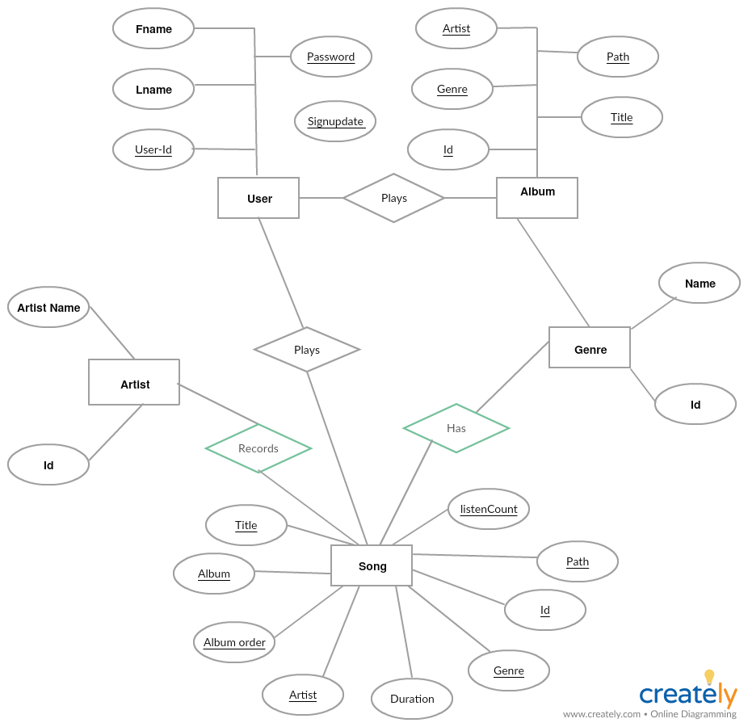

**4.5 Class Diagram**

A class diagram is a graph of classified elements connected by their various static relationships. It is shown here for Client Support System. This includes the System and the End-users as its main classes. Here are three different fields: Class, Attributes, and Operations.

Class shows the class name, i.e., System, End-user, Data and Sign Clip. They are connected with each other through links and their relation with each other is shown through the numbers represented on the link; here **\*** indicates zero or more multiplicity. Here Data class is connected to System through a Composition link which is the collaboration of all participants are part of one composite class.

Attributes provide the details of the Class while Operations show all possible operations respective class can do in the system.

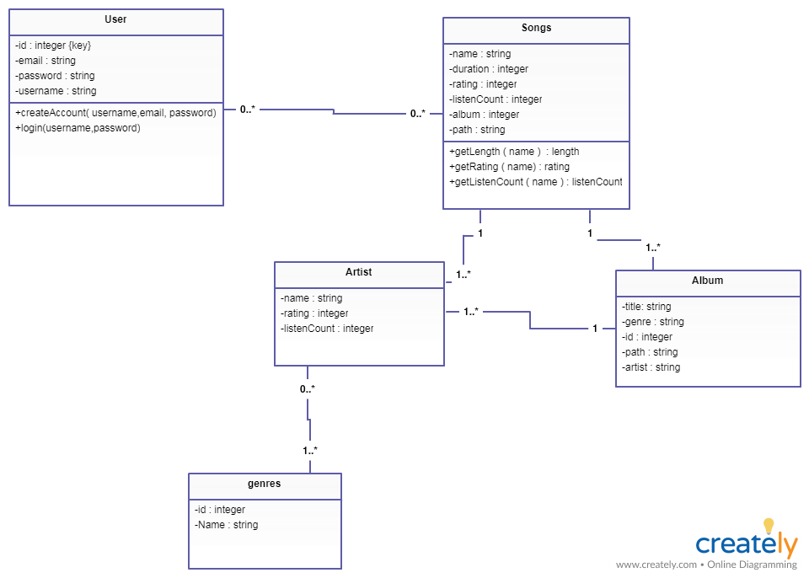

**Class Diagram for Songbook**

**4.5 System Activity**

A use case diagram shows the relationship among actors and use cases within a system. Hence it provides the characteristics of the actors whose behavior and relationships can be well understood using the diagrams elaborated here.

An end-user can perform various tasks on the application; he may use signs or upload a new sign o his own. On the other hand, the system would respond to the operations done by the user. It would display the sign clips and store the uploaded sign to the defined category. Also it would provide a message whenever needed for confirmation.

Here the rectangle indicates system boundary, out of which there are actors found who perform various operations on the system which are the end-user and the system here. An elliptical shape shows the use-case while the connecting links between an actor and a use case are said to be communicates.

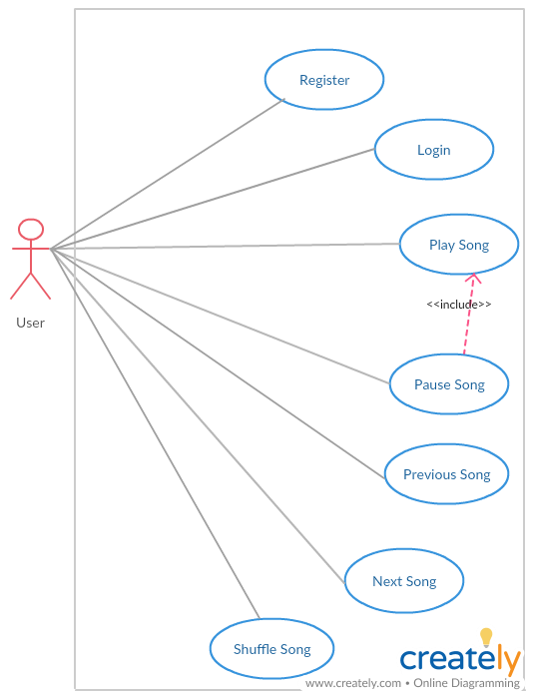

**Use-Case for Songbook**

**4.6 Sequence Diagram**

A sequence diagram represents an Interaction, which is a set of messages exchanged among objects within collaboration to effect a desired operation or result. Here are the sequence diagrams for various interactions among the user, system and the data storage. It must be noted that the rectangle box on the top of the diagram indicates the object or actor and dashed lines beneath to it shows an object’s lifeline. Another rectangles following and followed by the dashed lines in a vertical manner show the activation period of the object or actor when it performs some actions. A solid arrow conveys a message while the dashed arrow gives return message. These message names are written along with their respective arrows as shown further in the diagram.

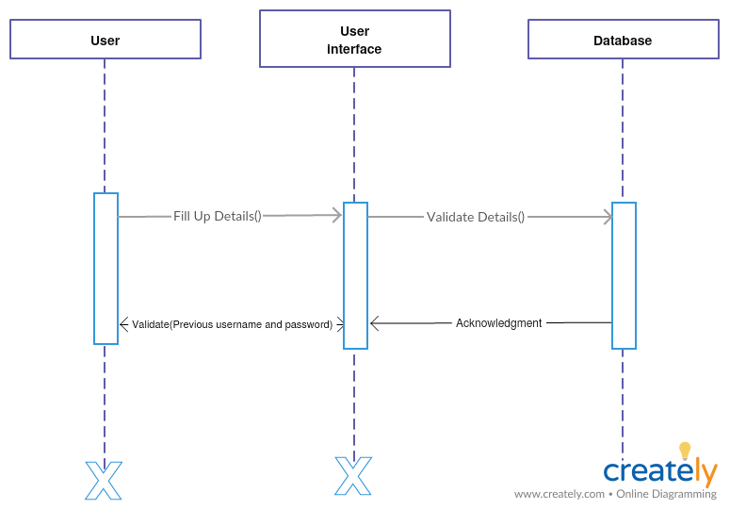

**Sequence Diagram for Registration**

# 

# 5 SYSTEM DESIGN

**5.1 Database Design**

The current web application uses Oracle Database to store, access and retrieve the data.

Following is the data dictionary that describes the required tables along with their fields.

**5.1.1 user Details:**

The following table is used to store user details for logging in

|  |  |  |  |
| --- | --- | --- | --- |
| **Field** | **Data Type** | **Length** | **Constraint** |
| username | varchar2 | 150 | not null |
| Password | varchar2 | 128 | not null |
| email | varchar2 | 200 | not null |
| id | int | 11 | Primary key |

Table 5.1 user Details

**5.1.2 songs Details:**

The following table is uses to store each song’s details

|  |  |  |  |
| --- | --- | --- | --- |
| **Field** | **Data Type** | **Length** | **Constraint** |
| id | int | 11 | Primary Key |
| title | varchar | 250 | not null |
| artist | int | 11 | not null |
| album | int | 11 | not null |
| genre | int | 11 | not null |
| duration | varchar | 8 | not null |
| path | varchar | 250 | not null |
| albumOrder | int | 11 | not null |
| plays | int | 11 | not null |

Table 5.2 songs Details

**5.1.3 artists Details:**

The following table is uses to store artist details:

|  |  |  |  |
| --- | --- | --- | --- |
| **Field** | **Data Type** | **Length** | **Constraint** |
| Id | int | 11 | Primary Key |
| Name | Varchar | 150 | not null |

Table 5.3 artists Details

**5.1.4 album Details:**

The following table is uses to store album details:

|  |  |  |  |
| --- | --- | --- | --- |
| **Field** | **Data Type** | **Length** | **Constraint** |
| id | Int | 11 | Primary Key |
| title | varchar | 50 | not null |
| artist | Int | 11 | not null |
| genre | Int | 11 | not null |
| artworkPath | varchar | 500 | not null |

Table 5.5 album Details

**5.1.5 genre Details:**

The following table is uses to store call log details:

|  |  |  |  |
| --- | --- | --- | --- |
| **Field** | **Data Type** | **Length** | **Constraint** |
| Id | Int | 11 | Primary Key |
| Name | varchar | 150 | not null |

Table 5.5 genre Details

# 6 BIBLIOGRAPHY

**6.1 Conclusion**

Songbook is a music streaming service that has a large collection of Indian and International music available free to the users no matter where they are. It is a ONE STEP SOLUTION for all type of music needs.

In Songbook users can create their own playlist , they can add song s of their favourite artist to the playlist and listen to the songs on the go.

Songbook allows users to listen music anytime, anywhere.

**6.2 Bibliography**

**Web Resources**

* [www.developer.mozilla.org](http://www.developer.mozilla.org)
* [www.mysql.com](http://www.mysql.com)
* [www.stackoverflow.com](http://www.stackoverflow.com)
* https://jquery.com

**Books**

* SQL, PL/SQL by Ivan Bayross, BPB Publications
* Object Oriented Modelling and Design with UML (second edition)

by Michael Blaha and James Rambaugh

* Software Engineering by Roger S. Pressman